LEGAL LIMIT OF INTERESTS

Through this document, an opinion is issued regarding the limits in which it is convenient to charge interest by non-banking institutions.

In accordance with the provisions of article 231 of the Criminal Code for Mexico City, it is established that the revenues or profits obtained as usurious advantages through contracts or agreements superior to those in force in the banking financial system, could generate penalties as transcribed next:

Article 231. The penalties provided for in the previous article will be imposed on those who:

(…)

X. Using the ignorance or poor economic conditions of a person, obtain usurious advantages from them through contracts or agreements in which revenues or profits are stipulated that are higher than those in force in the banking financial system.

Now, to know the interest market that is operated by the banks, the National Bank of Mexico discloses through its website the Total Annual Cost (CAT) that credit institutions apply to their products, locating for credit cards the one that turns out to be the most lucrative and that turns out to be 133.7% as of November 2022, as shown below:

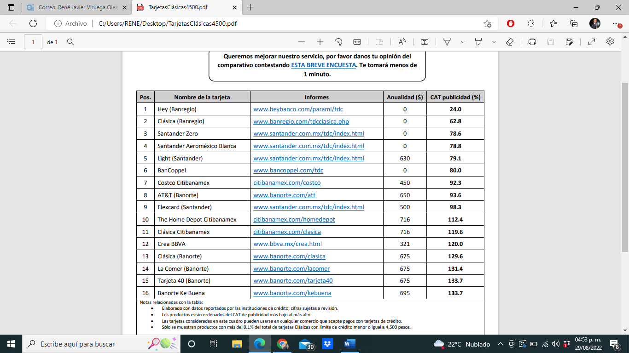

It is in consideration of the foregoing that it is recommended that the average amount of interest and other revenues and profits that are made in the granting of a loan, do not exceed in any circumstance 133.7% per year. This amount, also, should be revised year after year.

Sincerely,

RUSCONI & SAUZA, S.C.

https://www.banxico.org.mx/tarjetascat/
The CAT is a standardized measure that reflects the total value of a financing since it incorporates all the costs and expenses that are associated with the use of the credit and that in the end are required from the person requesting the loan.

